|  |  |  |
| --- | --- | --- |
| **Rothamsted weather data – exercise for secondary schools** |  |  |

----------------------------------------------------------

Looking back to plan ahead!

**Important:** You will require a password to extract data from the e-RA database – contact the e-RA curators in advance by email to obtain a password (res.era@rothamsted.ac.uk)

In this exercise, we are looking at the advantages of keeping good information about our experiments. Rothamsted has developed e-RA, the electronic Rothamsted Archive, to keep the results of **the long term experiments** and other information like **weather data**. A state of the art Web Application helps scientists and the public find information stored in e-RA. Computer scientists make programs to analyse the information.

# Collecting weather information every day: Select a date from ‘SCHOOLMETDAY (perhaps your birthday!)

1. On this day ____________________________

at its coldest it was ______________ and at its hottest it was __________________.

The mean was: ____________________. There were ______________mm of rain.

1. *In my day, those of my parents and grandparents… Let’s see what happens in sets of10 years over the last 120 years: complete the graph by plotting the data in the table.*

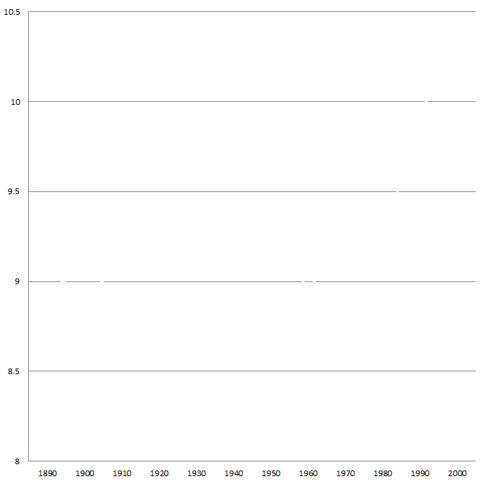

|  |  |
| --- | --- |
| 1890-99 | 9.04 |
| 1900-09 | 8.94 |
| 1910-19 | 9.07 |
| 1920-29 | 9.02 |
| 1930-39 | 9.24 |
| 1940-49  Temperature degrees C | 9.36 |
| 1950-59 | 9.32 |
| 1960-69 | 8.95 |
| 1970-79 | 9.25 |
| 1980-89 | 9.22 |
| 1990-99 | 9.93 |
| 2000- | 10.4  Date |

1. Weather for a whole year: **2011**

**Graph showing the daily T-max, T-min and mean temperature for 2011**

**(data extracted from the dataset for schools called ‘SCHOOLMETDAY’)**

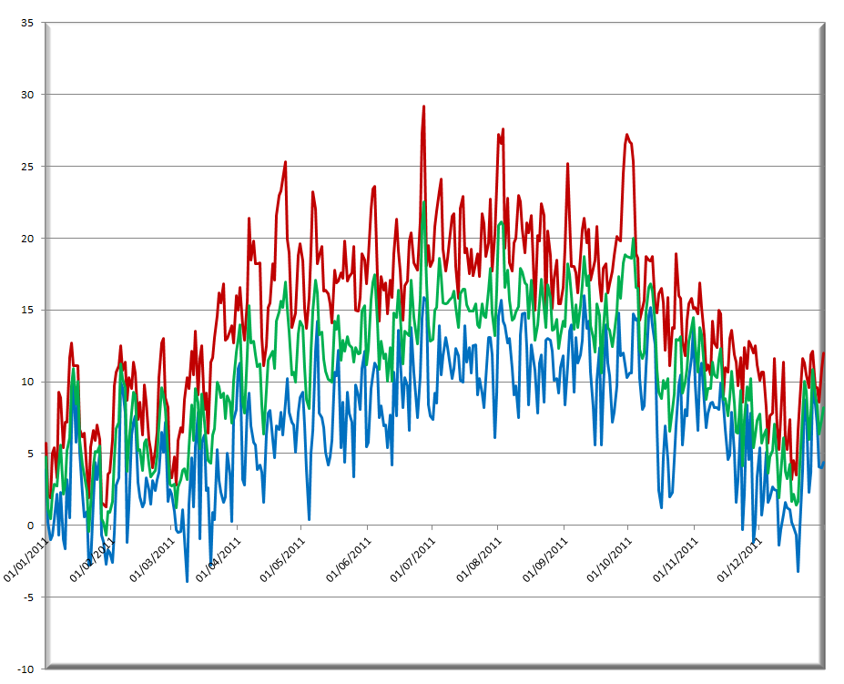

Date

Temperature degrees C

|  |  |
| --- | --- |
|  |  |

The blue line represents the **coldest** temperature every day,

the red line: the **hottest**,

and the green line the **mean**.

The average temperature for that year would be the average of all the means. (That is a good enough approximation). Average: 10.84 ⁰C

1. ***Your turn….!***

*Now you extract data for one year from e-RA dataset ‘SCHOOLMETDAY’ and use excel to analyse it…*

|  |  |  |  |
| --- | --- | --- | --- |
| **Year** | 2011 |  |  |
| **Hottest day** | 27 June: 29.2⁰C |  |  |
| **Coldest day** | 8 March:-3.9⁰C |  |  |
| **Average temp** | 10.84⁰C |  |  |
| **Wettest day** |  |  |  |
| **Driest day** |  |  |  |
| **Sunniest day** |  |  |  |
| **Windiest day** |  |  |  |

1. In my days, those of my parents, grandparents …